CS 305 Module Two Written Assignment
Lawrence Langelier 03/14/26

Areas of Security
Following the Vulnerability Assessment Process Flow Diagram, the first step is to perform an architecture review to understand how the application is designed and where security risks may exist. The provided code base is a Spring Boot web application that exposes REST endpoints through a controller. These endpoints allow users to send requests and receive responses from the server.

Based on this architecture review, several security areas from the first level of the diagram were identified as relevant for further assessment. These include input validation, APIs, client/server interaction, code errors, code quality, and encapsulation. Input validation is important because the application receives data from users through request parameters and path variables. The API layer must also be reviewed because the endpoints act as entry points where users interact with the system.

Client/server interaction is another relevant area because the server must safely handle requests coming from external clients. Code error handling and code quality are also important to examine since improper handling of user input can cause unexpected behavior or application errors. Finally, encapsulation should be reviewed to ensure that internal data structures are properly protected.

Areas of Security Justification
After identifying the relevant security areas during the architecture review stage of the Vulnerability Assessment Process Flow Diagram, the next step is to explain why these areas are important for this application. The diagram highlights several security areas that should be evaluated when reviewing a web application that accepts user input.

Input validation is important because the application accepts data from users through request parameters and path variables. If user input is not validated, it could allow malicious or unexpected data to be processed by the application.

The API layer is also relevant because the application exposes endpoints that allow users to interact with the system through HTTP requests. These endpoints act as entry points where attackers could attempt to send harmful input.

The client/server interaction area is important because the server receives requests from external clients and must safely process those requests without trusting the input automatically. Code error handling is also relevant because incorrect input values could cause runtime errors or unexpected behavior in the program.

Finally, code quality and encapsulation should be reviewed because secure coding practices help reduce vulnerabilities. Encapsulation protects internal data structures, while good code quality helps ensure that input is handled safely and consistently throughout the application.

Following the areas identified in the diagram helps guide the manual code review and ensures that the most important security risks are examined.

Code Review Summary
Following the Vulnerability Assessment Process Flow Diagram, the next step after identifying the relevant security areas is to move to the second level of the process and perform a manual code review. I imported the provided code base into Eclipse so the source files could be examined more closely.

During the manual review, the main file inspected was GreetingController.java, which contains the controller methods that handle user requests. Since this file processes input from users through the application’s API endpoints, it was the most important area to evaluate.

One issue identified during the review appears in the /greeting endpoint. The application accepts a user-provided name parameter and passes it directly into the Spring Expression Language parser using parseExpression(). Because the input is not validated first, a malicious user could potentially provide an expression instead of a normal name, which may cause unintended behavior.

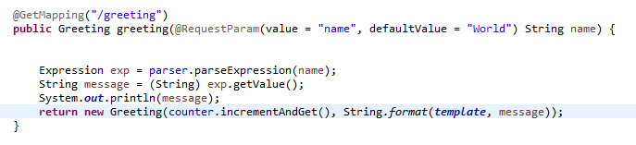

Another issue was found in the /number/{id} endpoint. The value provided by the user is used directly as an array index without checking whether the number is within the valid range of the array. If a user enters a value outside the array bounds, the application may throw an error and cause the request to fail.

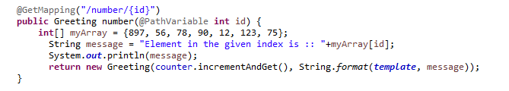

I also reviewed other files in the project, such as Greeting.java. This class serves as a simple data model and does not process user input, so no major security concerns were identified in that file.

Mitigation Plan
To reduce the security risks found during the manual code review, the application should avoid passing user input directly into the Spring Expression Language parser. Instead of treating user input as an expression, the program should treat it as plain text. This would prevent users from entering expressions that could be interpreted in an unsafe way.

The application should also add input validation before using any values provided by the user. In the /greeting endpoint, the name value should be checked to make sure it only contains expected text. In the /number/{id} endpoint, the program should verify that the number is within the valid range of the array before trying to access it. If the input is invalid, the application should return a safe error message instead of failing.

Another mitigation technique is to improve error handling so the application can respond safely when bad input is received. In addition, the development team should review the project configuration and dependencies to resolve the startup conflict and make sure the application can run correctly. Using safer input handling, validation checks, and stronger configuration practices would improve the overall security and stability of the application.

Conclusion
Following the Vulnerability Assessment Process Flow Diagram helped guide the security review of the application. The architecture review identified key areas of security that needed to be examined, and the manual code review helped reveal potential vulnerabilities related to how user input is handled in the controller methods. Issues such as evaluating user input through the Spring Expression Language parser and using user input directly as an array index highlight how improper input validation can create security risks in a web application.

This process also relates to the static testing performed in the Module Two coding assignment. While the manual review focused on identifying vulnerabilities within the application’s source code, the dependency-check tool was used to automatically scan the project’s external libraries for known vulnerabilities listed in the National Vulnerability Database (NVD). Using both manual code review and automated dependency scanning provides a more complete security assessment by identifying risks in both the application code and the third-party components it relies on.

